1.

[SELECT](http://localhost/phpmyadmin/url.php?url=https://dev.mysql.com/doc/refman/8.0/en/select.html) * FROM venta INNER JOIN usuario ON (venta.vent_codigo = usuario.usua_codigo) [AND](http://localhost/phpmyadmin/url.php?url=https://dev.mysql.com/doc/refman/8.0/en/logical-operators.html%23operator_and) (venta.vent_codigo = usuario.usua_codigo);

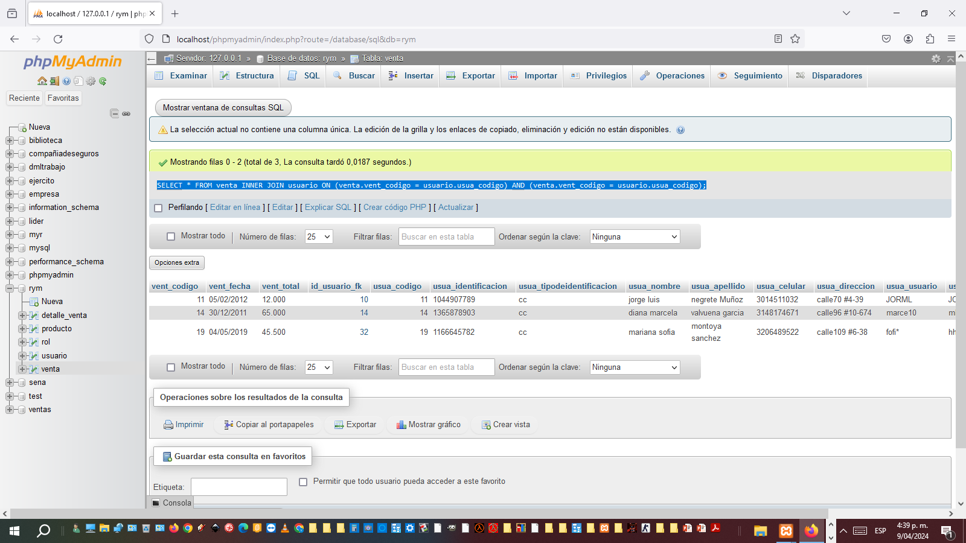

2.

[SELECT](http://localhost/phpmyadmin/url.php?url=https://dev.mysql.com/doc/refman/8.0/en/select.html) * FROM rol INNER JOIN venta ON (rol.rol_codigo= venta.vent_codigo) [AND](http://localhost/phpmyadmin/url.php?url=https://dev.mysql.com/doc/refman/8.0/en/logical-operators.html%23operator_and) (rol.rol_codigo =venta.vent_codigo);

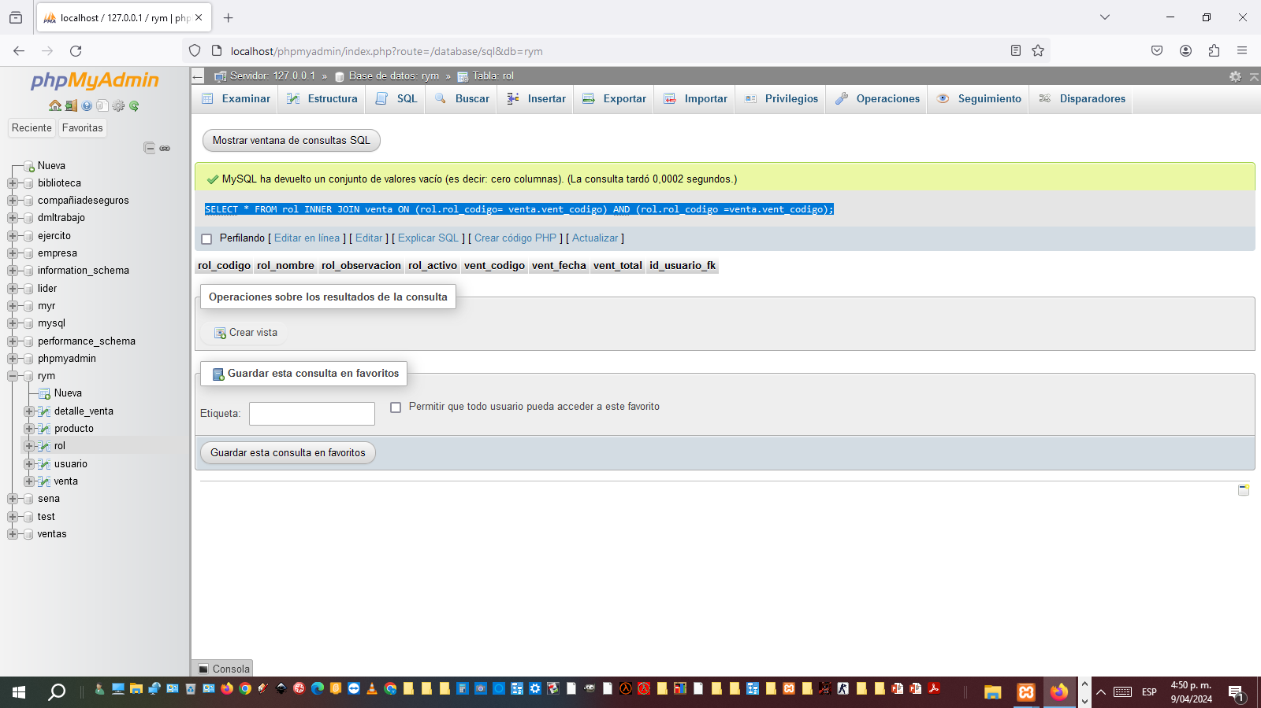

3.

[SELECT](http://localhost/phpmyadmin/url.php?url=https://dev.mysql.com/doc/refman/8.0/en/select.html) * FROM venta INNER JOIN producto ON (venta.vent_codigo= producto.prod_codigo) [AND](http://localhost/phpmyadmin/url.php?url=https://dev.mysql.com/doc/refman/8.0/en/logical-operators.html%23operator_and) (venta.vent_codigo=producto.prod_codigo);

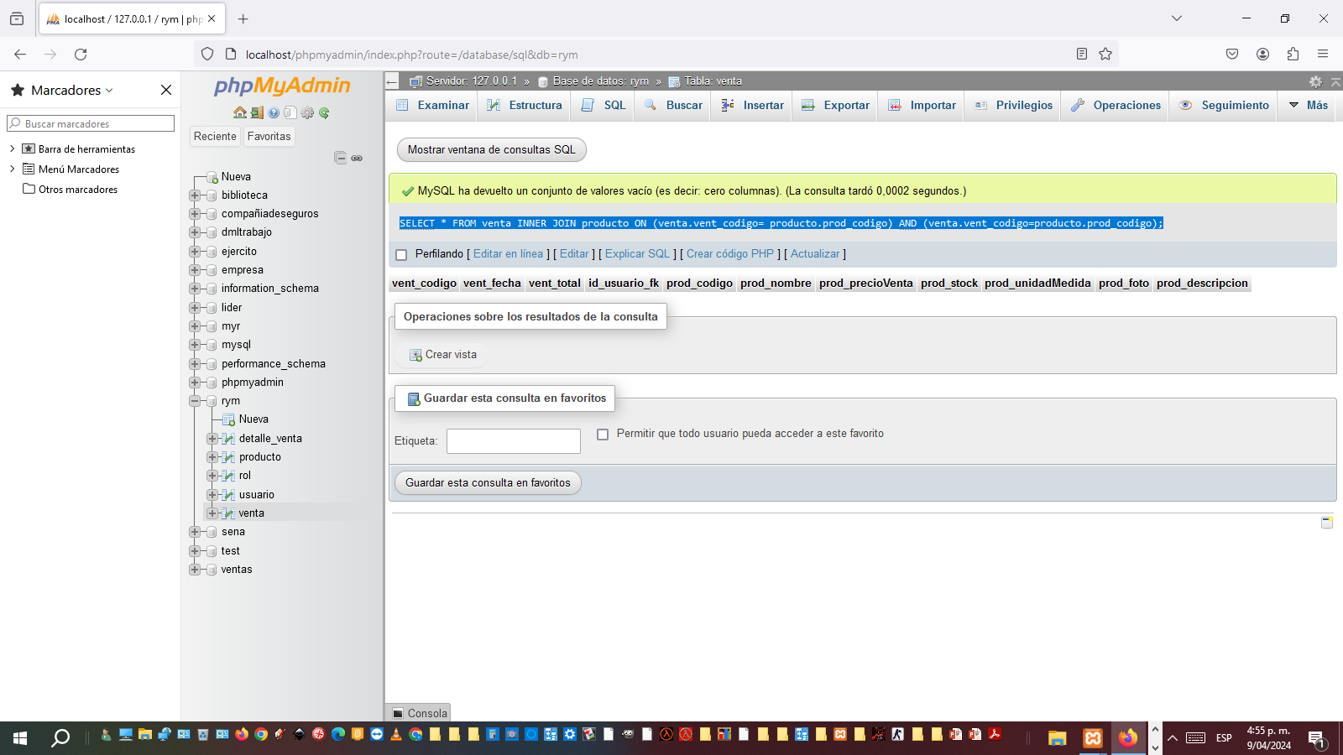

4.

[SELECT](http://localhost/phpmyadmin/url.php?url=https://dev.mysql.com/doc/refman/8.0/en/select.html) * FROM rol INNER JOIN usuario ON (rol.rol_codigo= usuario.usua_codigo) [AND](http://localhost/phpmyadmin/url.php?url=https://dev.mysql.com/doc/refman/8.0/en/logical-operators.html%23operator_and) (rol.rol_codigo=usuario.usua_codigo);

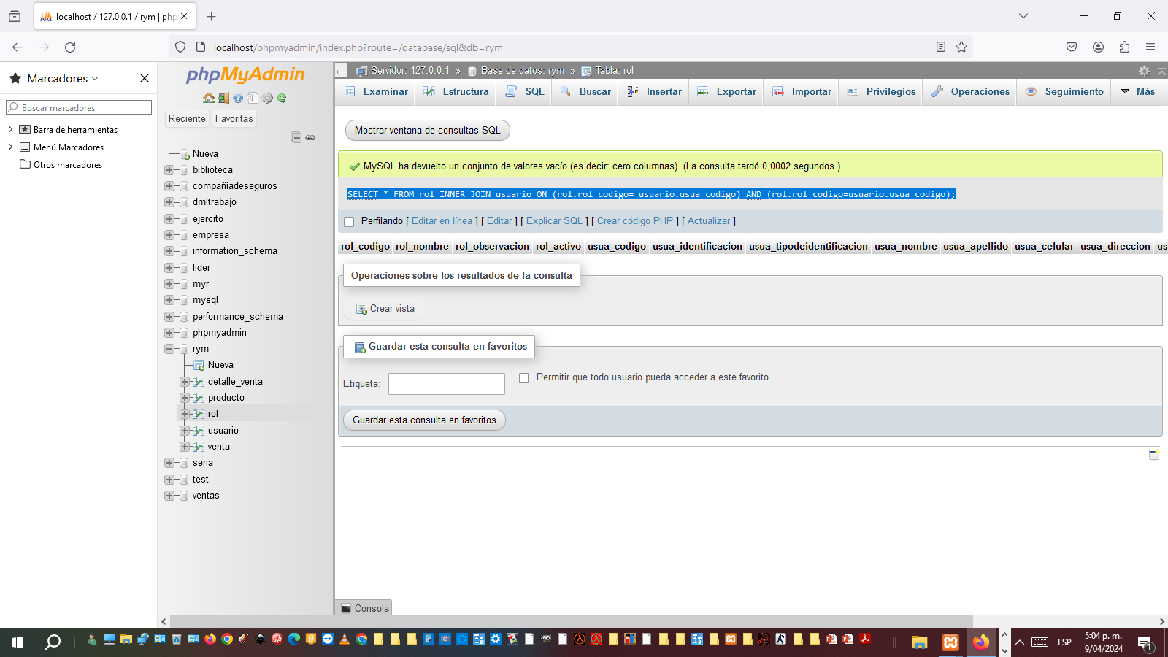

5

[SELECT](http://localhost/phpmyadmin/url.php?url=https://dev.mysql.com/doc/refman/8.0/en/select.html) * FROM producto INNER JOIN venta ON (producto.prod_codigo= venta.vent_codigo) [AND](http://localhost/phpmyadmin/url.php?url=https://dev.mysql.com/doc/refman/8.0/en/logical-operators.html%23operator_and) (producto.prod_codigo=venta.vent_codigo);

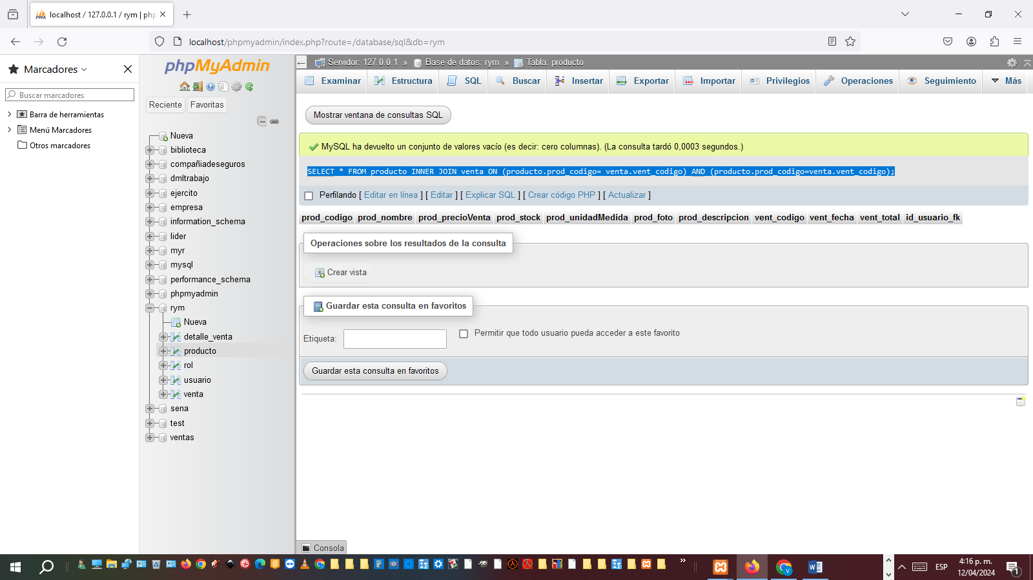

6. [SELECT](http://localhost/phpmyadmin/url.php?url=https://dev.mysql.com/doc/refman/8.0/en/select.html) * FROM detalle_venta INNER JOIN venta ON (detalle_venta.deve_codigo= venta.vent_codigo) [AND](http://localhost/phpmyadmin/url.php?url=https://dev.mysql.com/doc/refman/8.0/en/logical-operators.html%23operator_and) (detalle_venta.deve_codigo=venta.vent_codigo);

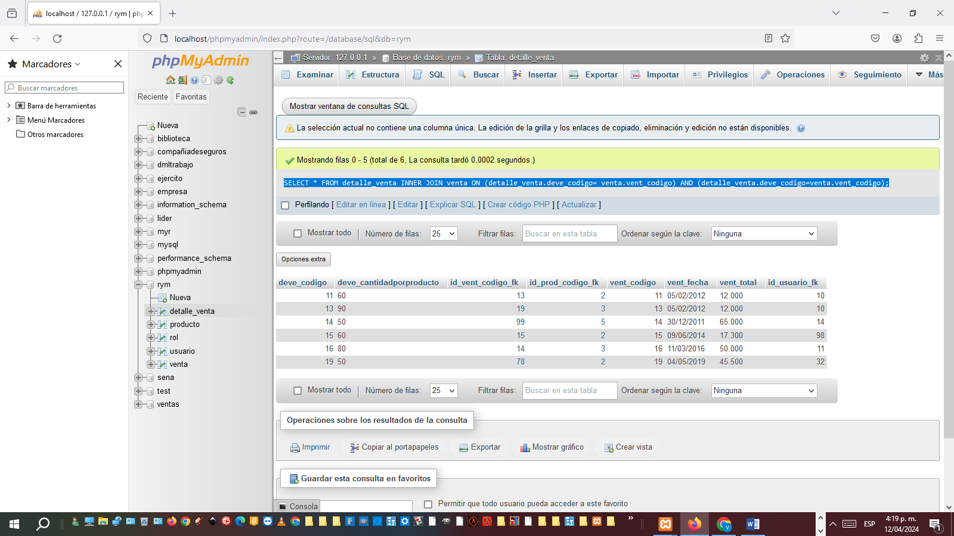

[CREATE](http://localhost/phpmyadmin/url.php?url=https://dev.mysql.com/doc/refman/8.0/en/create-view.html) [VIEW](http://localhost/phpmyadmin/url.php?url=https://dev.mysql.com/doc/refman/8.0/en/create-view.html) v_m_a as [SELECT](http://localhost/phpmyadmin/url.php?url=https://dev.mysql.com/doc/refman/8.0/en/select.html) rol.rol_codigo as rol, concat(usuario.usua_codigo,'', usuario.usua_codigo ) AS usuario FROM rol AS rol INNER JOIN usuario AS usuario ON rol.rol_codigo=usuario.usua_codigo order by rol.rol_codigo,usuario.usua_codigo;

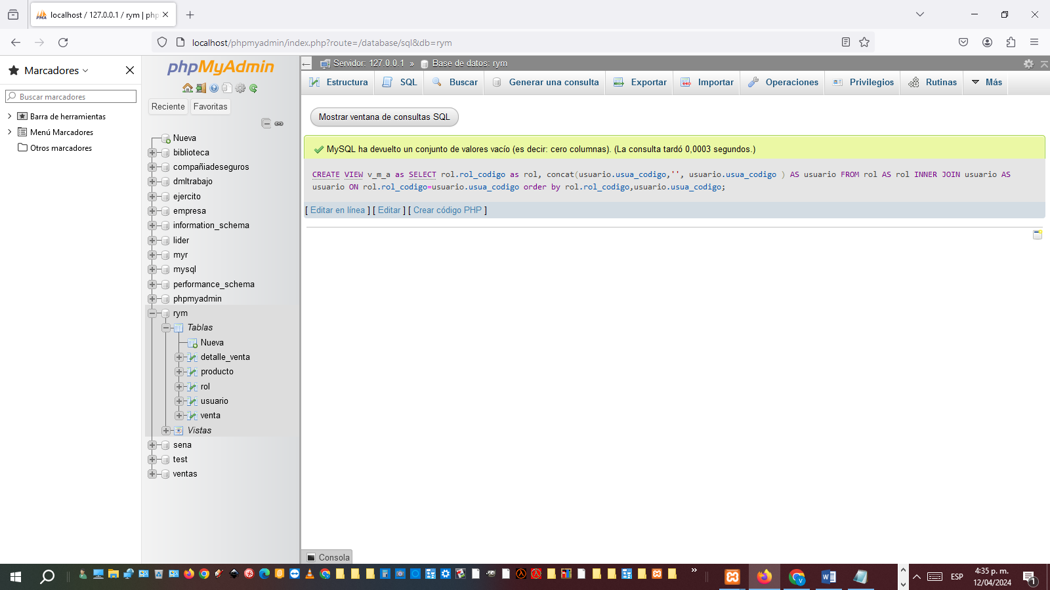

[CREATE](http://localhost/phpmyadmin/url.php?url=https://dev.mysql.com/doc/refman/8.0/en/create-view.html) [VIEW](http://localhost/phpmyadmin/url.php?url=https://dev.mysql.com/doc/refman/8.0/en/create-view.html) s_v_a as [SELECT](http://localhost/phpmyadmin/url.php?url=https://dev.mysql.com/doc/refman/8.0/en/select.html) usuario.usua_codigo as usuario, concat(venta.vent_codigo,'', venta.vent_codigo ) AS venta FROM usuario AS usuario INNER JOIN venta AS venta ON usuario.usua_codigo=venta.vent_codigo order by usuario.usua_codigo,venta.vent_codigo;

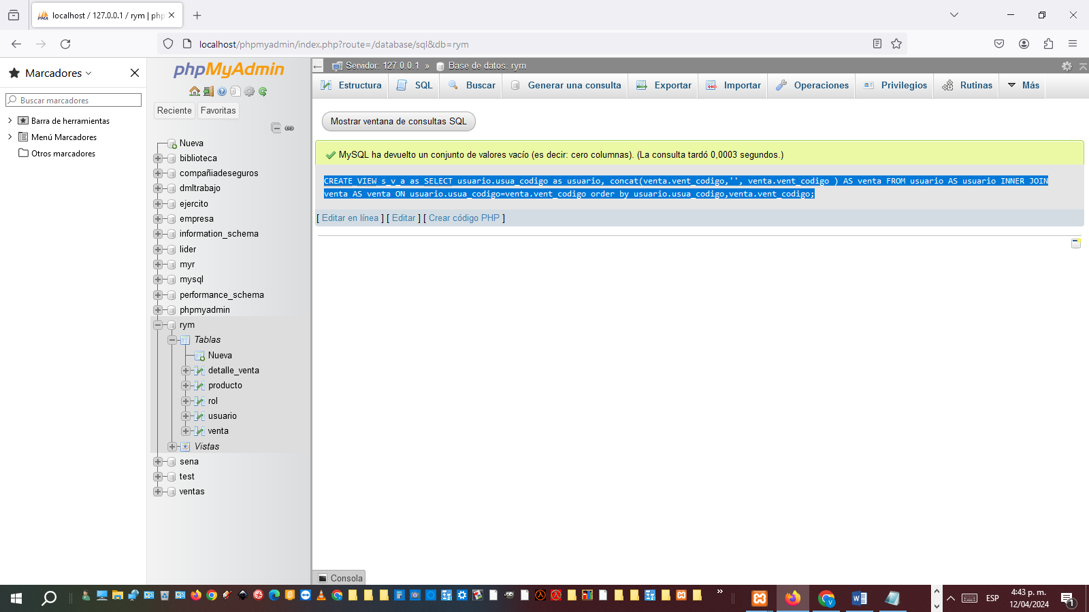

[CREATE](http://localhost/phpmyadmin/url.php?url=https://dev.mysql.com/doc/refman/8.0/en/create-view.html) [VIEW](http://localhost/phpmyadmin/url.php?url=https://dev.mysql.com/doc/refman/8.0/en/create-view.html) s_a_a as [SELECT](http://localhost/phpmyadmin/url.php?url=https://dev.mysql.com/doc/refman/8.0/en/select.html) producto.prod_codigo as producto, concat(venta.vent_codigo,'', venta.vent_codigo ) AS venta FROM producto AS producto INNER JOIN venta AS venta ON producto.prod_codigo=venta.vent_codigo order by producto.prod_codigo,venta.vent_codigo;

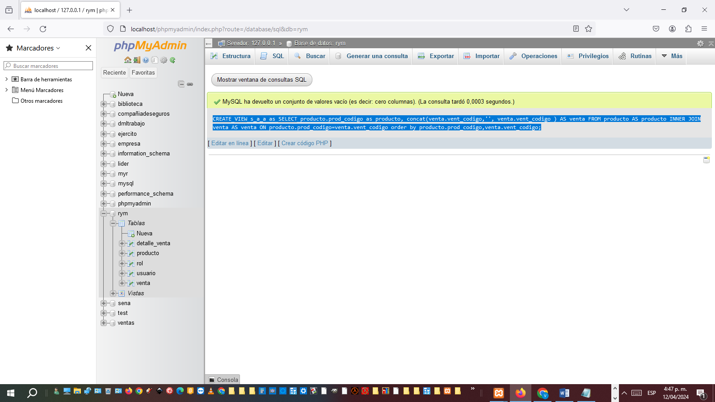

[CREATE](http://localhost/phpmyadmin/url.php?url=https://dev.mysql.com/doc/refman/8.0/en/create-view.html) [VIEW](http://localhost/phpmyadmin/url.php?url=https://dev.mysql.com/doc/refman/8.0/en/create-view.html) s_s_a as [SELECT](http://localhost/phpmyadmin/url.php?url=https://dev.mysql.com/doc/refman/8.0/en/select.html) producto.prod_codigo as producto, concat(usuario.usua_codigo,'', usuario.usua_codigo ) AS usuario FROM producto AS producto INNER JOIN usuario AS usuario ON producto.prod_codigo=usuario.usua_codigo order by producto.prod_codigo,usuario.usua_codigo;

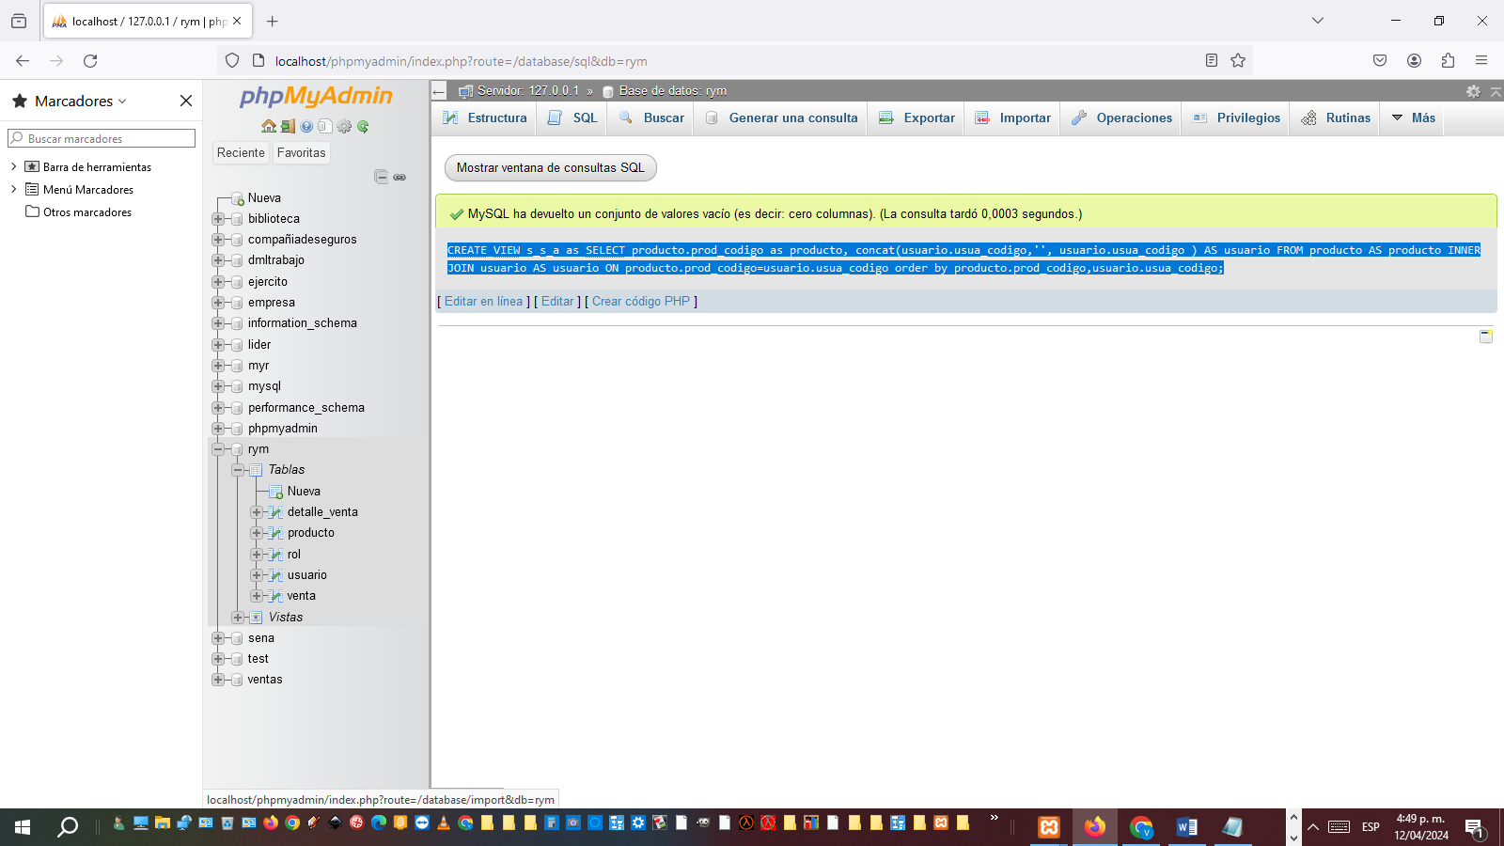

[CREATE](http://localhost/phpmyadmin/url.php?url=https://dev.mysql.com/doc/refman/8.0/en/create-view.html) [VIEW](http://localhost/phpmyadmin/url.php?url=https://dev.mysql.com/doc/refman/8.0/en/create-view.html) s_j_a as [SELECT](http://localhost/phpmyadmin/url.php?url=https://dev.mysql.com/doc/refman/8.0/en/select.html) venta.vent_codigo as venta, concat(usuario.usua_codigo,'', usuario.usua_codigo ) AS usuario FROM venta AS venta INNER JOIN usuario AS usuario ON venta.vent_codigo=usuario.usua_codigo order by venta.vent_codigo,usuario.usua_codigo;

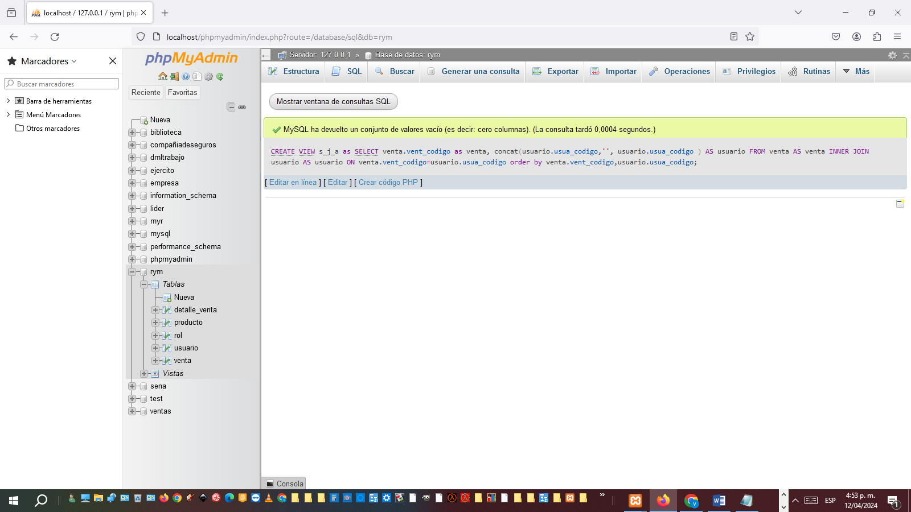

[CREATE](http://localhost/phpmyadmin/url.php?url=https://dev.mysql.com/doc/refman/8.0/en/create-view.html) [VIEW](http://localhost/phpmyadmin/url.php?url=https://dev.mysql.com/doc/refman/8.0/en/create-view.html) s_a_j as [SELECT](http://localhost/phpmyadmin/url.php?url=https://dev.mysql.com/doc/refman/8.0/en/select.html) rol.rol_codigo as rol, concat(venta.vent_codigo,'', venta.vent_codigo ) AS venta FROM rol AS rol INNER JOIN venta AS venta ON rol.rol_codigo=venta.vent_codigo order by rol.rol_codigo,venta.vent_codigo;

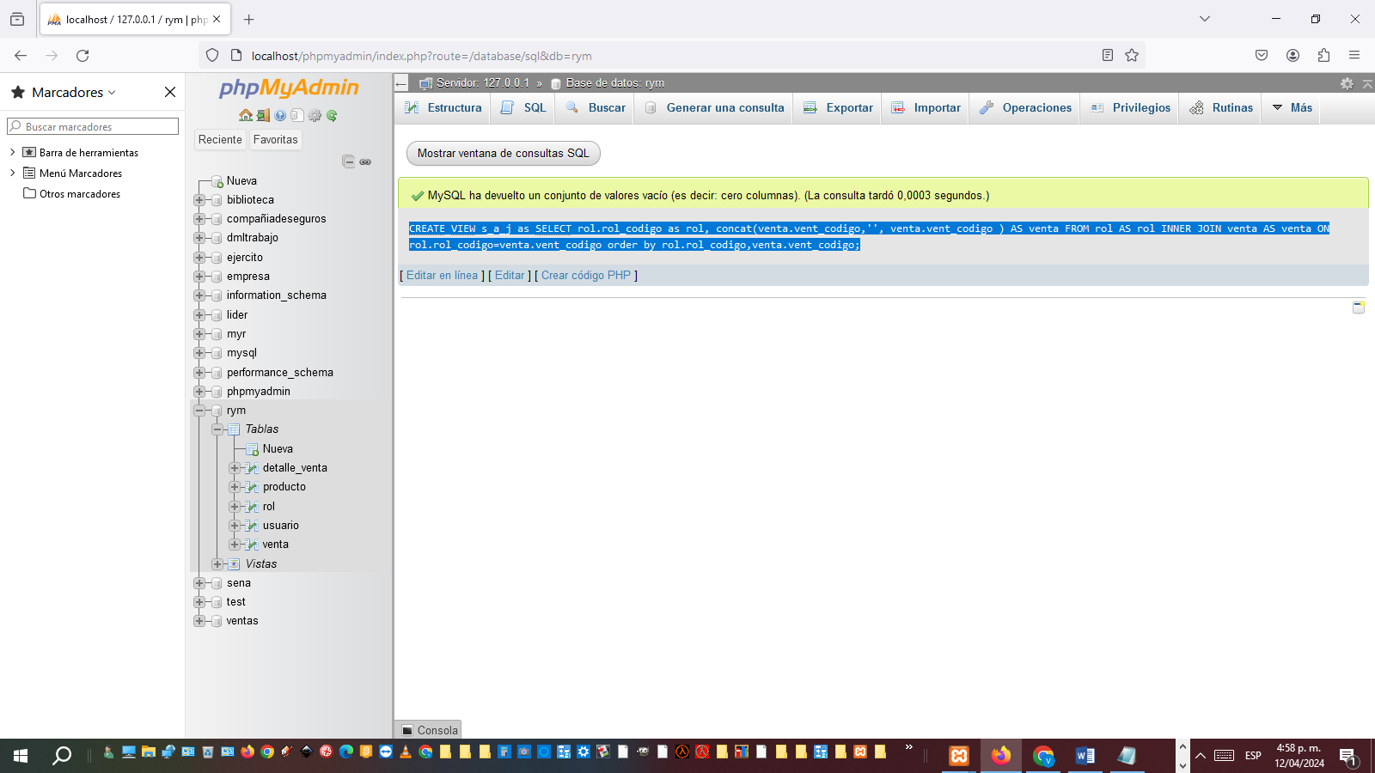

Vistas consulta multitabla

